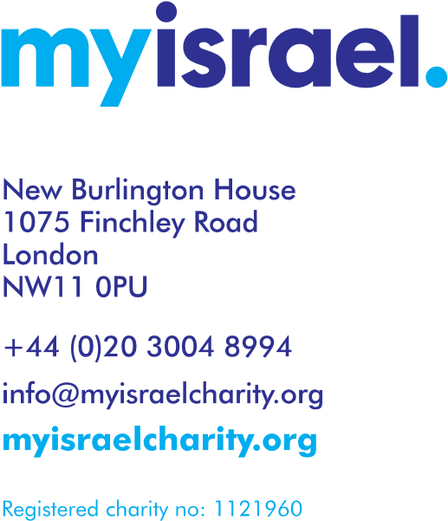

Gift Aid Declaration

Details of donor:

Name: _________________________________________________________________

Address: ________________________________________________________________

Post code: ________________________ email: _________________________________

Home phone: _______________________ mobile phone: ________________________

How did you hear about Myisrael? __________________________________________

I want the charity to treat all donations I have made in the past 4 years, and all donations I make from the date of this declaration until I notify you otherwise as Gift Aid donations.

Signature _______________________________ Date _________________________

Notes:

- If your declaration covers donations made in the future, you must notify Myisrael of a change in your name or address while the declaration is in force.

- You can cancel the declaration at any time by notifying Myisrael. It will then not apply to any donation you make on or after the date of the cancellation or such later date as you specify.

- You must pay an amount of income tax and/or capital gains tax at least equal to the tax that Myisrael reclaims (currently 25p for each £1 you give).
- If you pay less income tax and/or capital gains tax than the amount of Gift Aid claimed on all your donations in that tax year it is your responsibility to pay any difference.

- If, in future your circumstances change and you no longer pay tax on your income or capital gains tax equal to the tax that Myisrael reclaims, you can cancel your declaration.

- If you pay tax at the higher rate, you can claim further tax relief on your self-assessment tax return.

- If you are unsure whether your donations qualify for Gift Aid, ask Myisrael

(finance@myisraelcharity.org) or call your local tax office for leaflet IR113 Gift Aid

Donate with confidence

